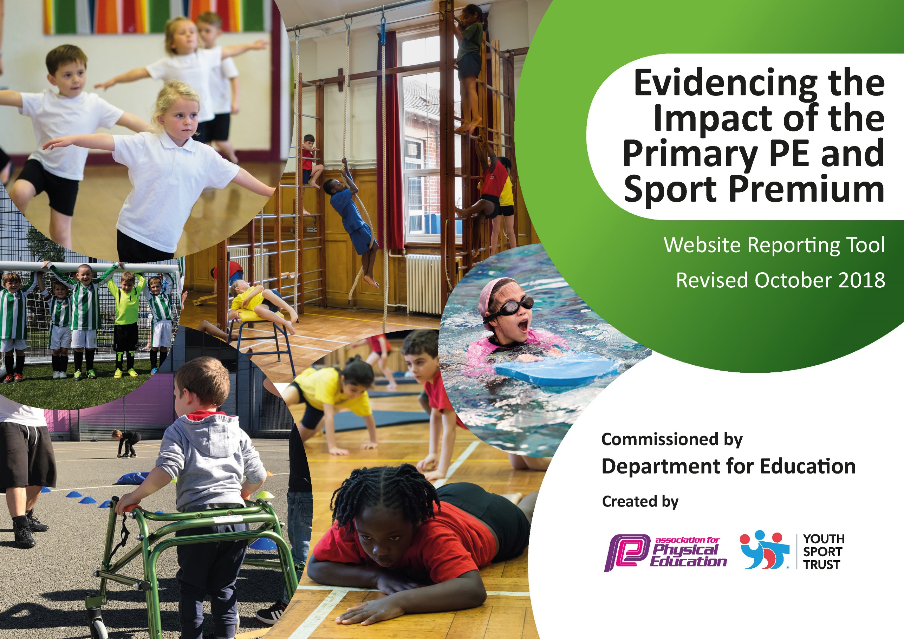
Year 2021-2022
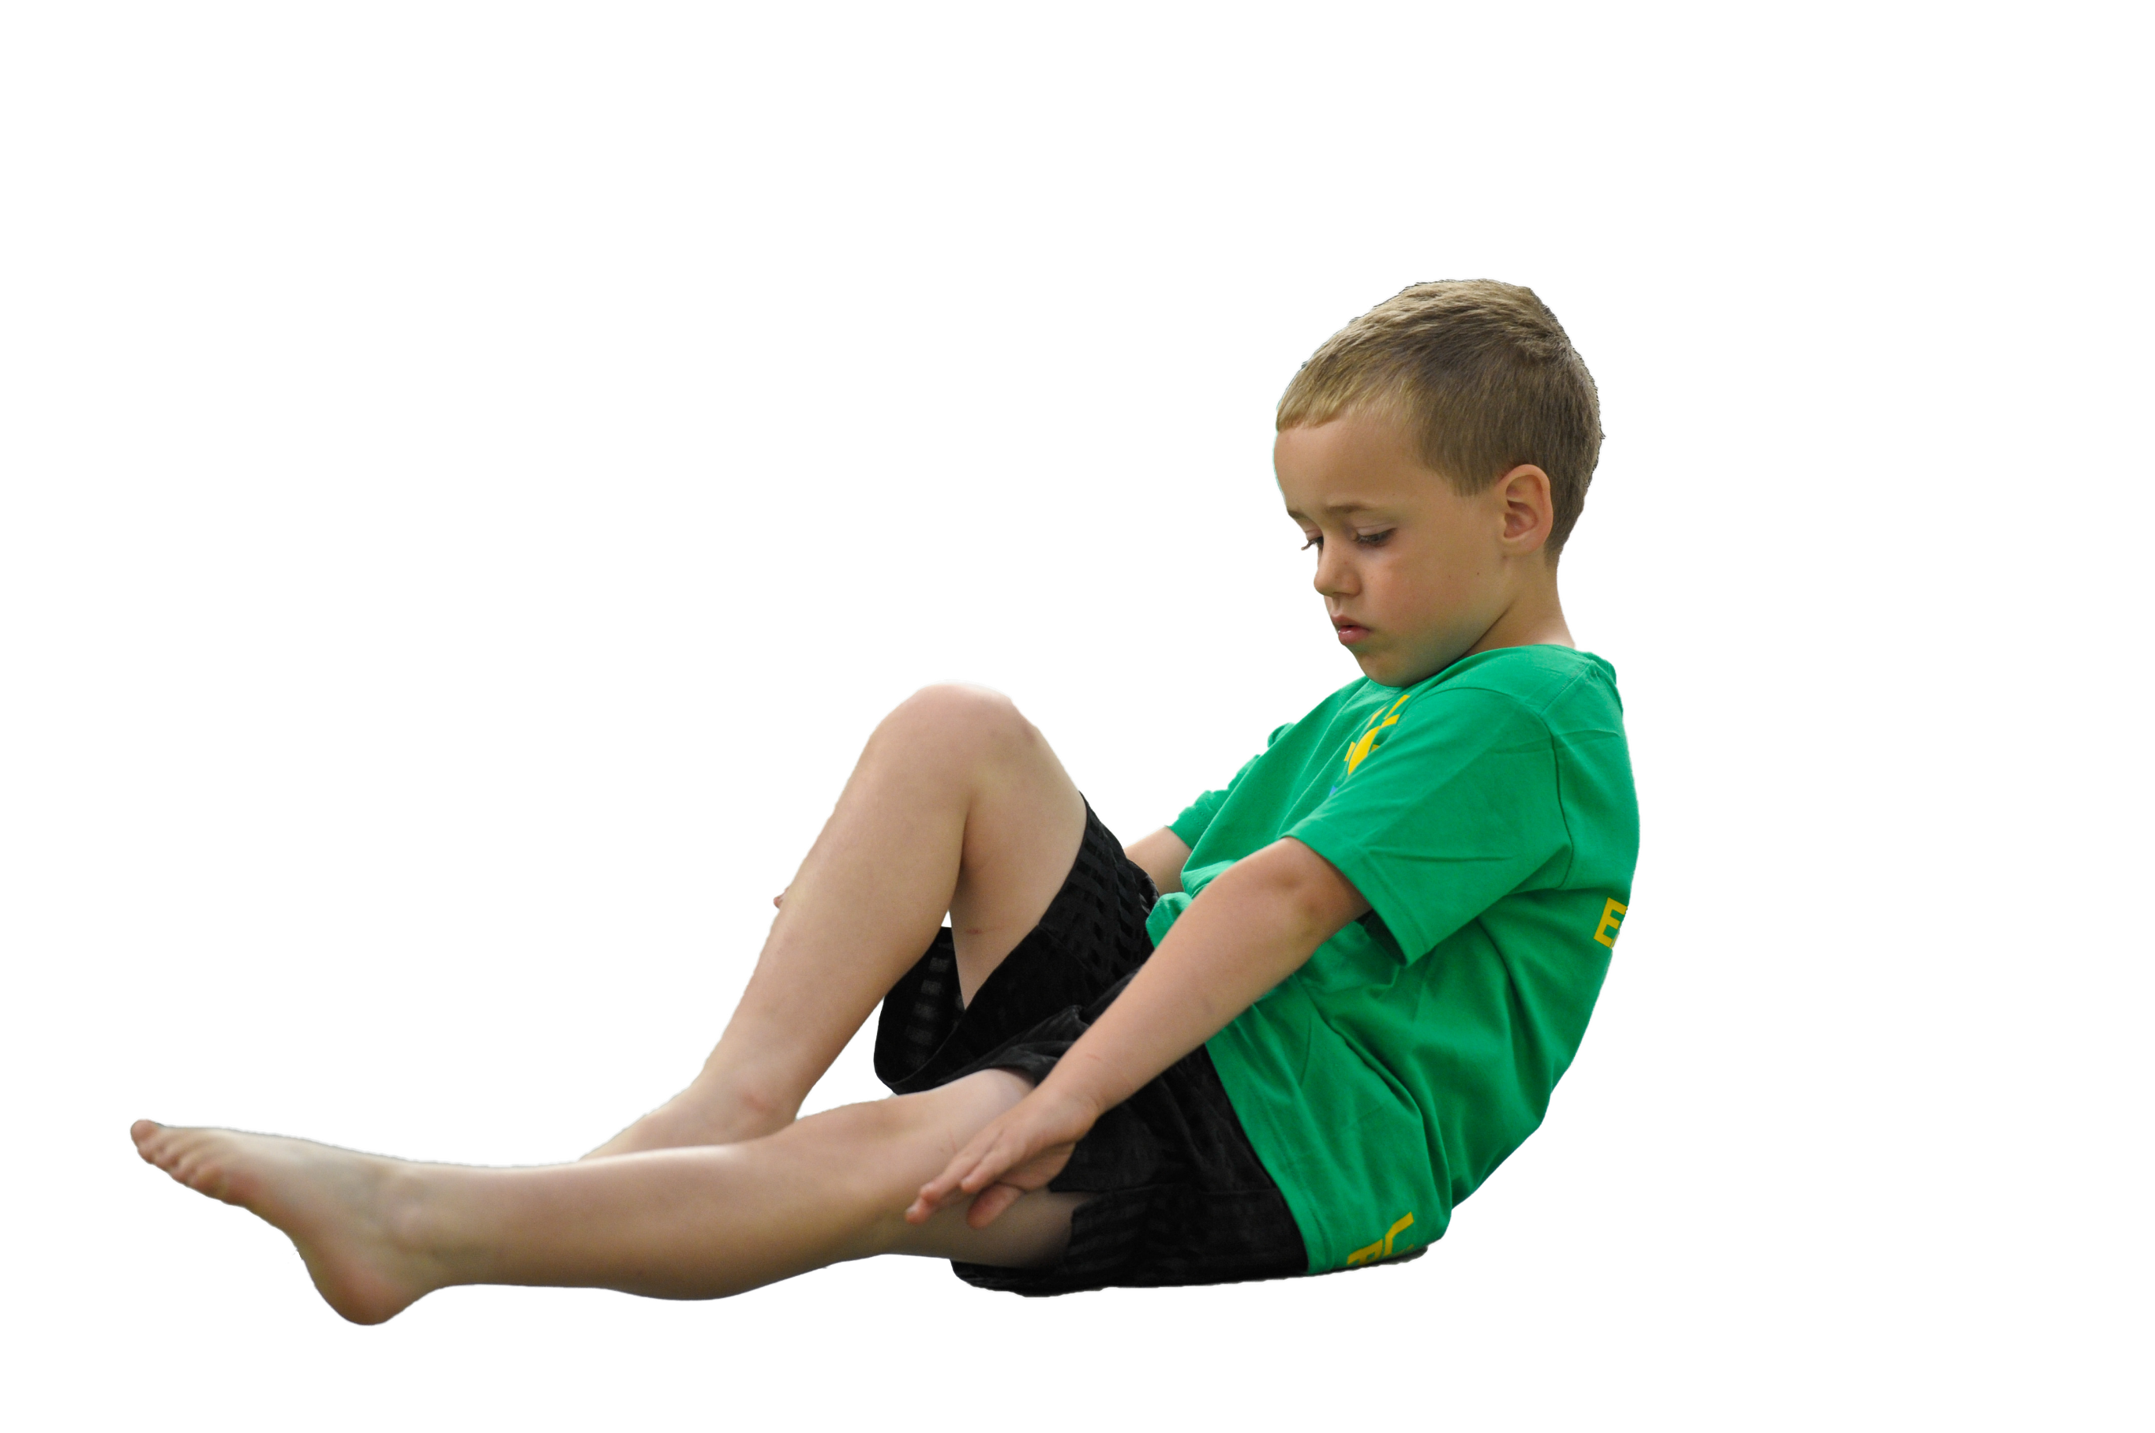
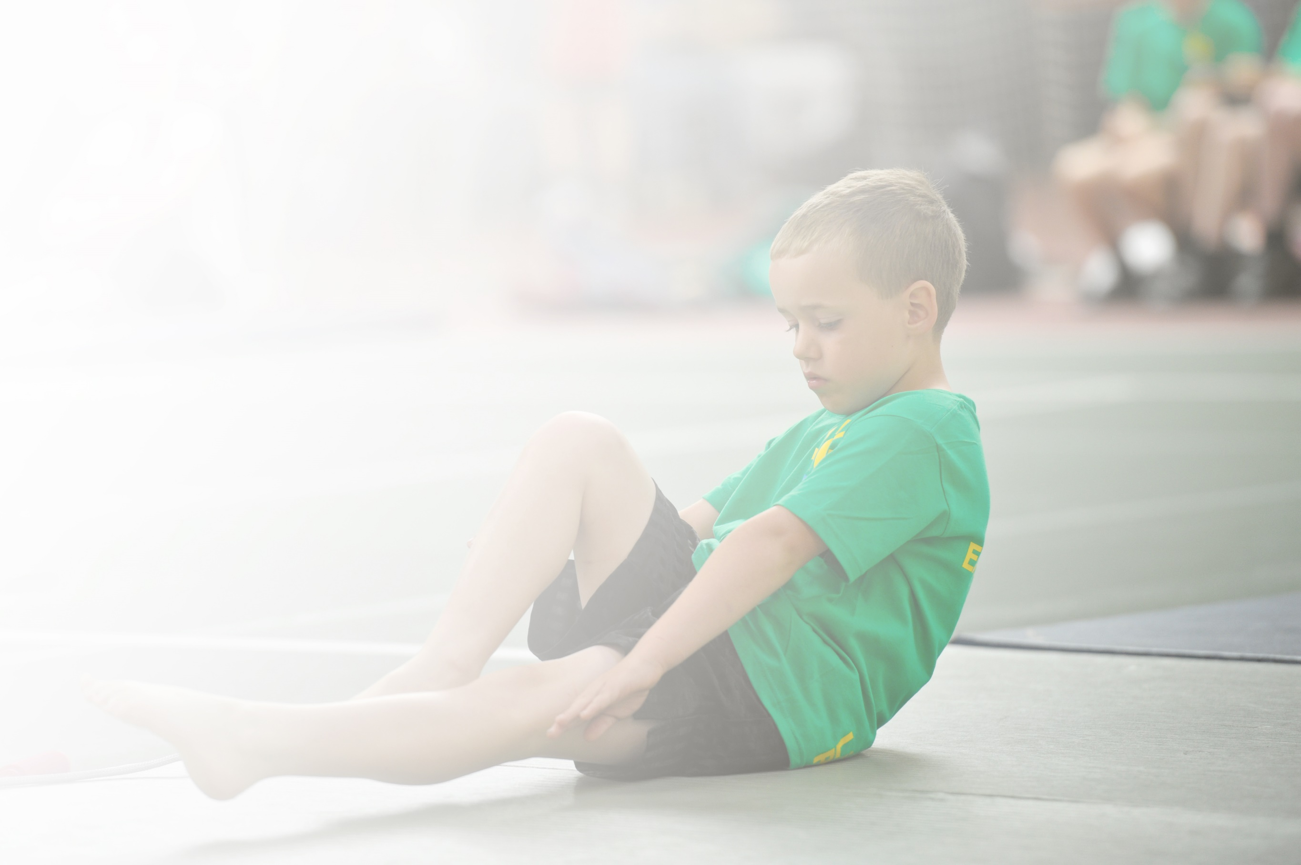
Schools must use the funding to make additional and sustainable improvements to the quality of Physical Education, Sport and Physical Activity (PESPA) they offer. This means that you should use the Primary PE and Sport Premium to:

- Develop or add to the PESPA activities that your school already offer
- Build capacity and capability within the school to ensure that improvements made now will benefit pupils joining the school in future years

Please visit gov.uk for the revised DfE guidance including the 5 key indicators across which schools should demonstrate an improvement. This document will help you to review your provision and to report
your spend. DfE encourages schools to use this template as an effective way of meeting the reporting requirements of the Primary PE and Sport Premium.

We recommend you start by reflecting on the impact of current provision and reviewing the previous
spend. Under the Ofsted Schools Inspection Framework, inspectors will assess how effectively leaders use the Primary PE and Sport Premium and measure its impact on outcomes for pupils, and how effectively governors hold them to account for this.

Schools are required to publish details of how they spend this funding as well as on the impact it has on pupils’ PE and sport participation and attainment by the end of the summer term or by 31 July 2022 at the
latest.
We recommend regularly updating the table and publishing it
on your website throughout the year, as evidence of your
ongoing review into how you are using the money to
secure maximum, sustainable impact. To see an
example of how to complete the table please
click HERE.

Support for review and reflection - considering the 5 key indicators from DfE, what development needs are a priority for your setting and your students now and why? Use the space below to reflect on previous spend, identify current need and priorities for the future.

Key achievements to date: | Areas for further improvement and baseline evidence of need:
- The new gym equipment is being utilised to increase physical activity within school.  - Being in the Top 10 schools in Bolton for participation in the Your School Games competitive sports. (Year 2019-20). Achieving all the necessary evidence to go for the Your School Games Gold Award for the year however, due to Covid 19, applications for this were suspended for the past two academic years. (Years 2019-20 And 2021-22)  - PE and Physical Activity continuing throughout Covid times.  - Wellbeing high on the agenda for the whole school.  - Restoring links and developing new links with sports coaches and clubs. | - Full re-engagement in the Your School Games in person events for the year with the aspiration to apply for the School Games Mark at the end of the academic year.  - Target least active children and engage them in physical activity.  - Aspire for all children in Year 6 to have represented school at sporting events within the academic year.  - Coaching and CPD for Gymnastics by a qualified coach.

Meeting national curriculum requirements for swimming and water safety | Please complete all of the below:
What percentage of your current Year 6 cohort swim competently, confidently and proficiently over a distance of at least 25 metres?  N.B. Even though your children may swim in another year please report on their attainment on leaving  primary school. | 42%
What percentage of your current Year 6 cohort use a range of strokes effectively [for example, front crawl, backstroke and breaststroke]? | 42%
What percentage of your current Year 6 cohort perform safe self-rescue in different water-based situations? | 32%
Schools can choose to use the Primary PE and Sport Premium to provide additional provision for swimming but this must be for activity over and above the national curriculum requirements. Have you used it in this way? | Yes  (Current Year 6 cohort did not have this due to Covid)

Action Plan and Budget Tracking
Capture your intended annual spend against the 5 key indicators. Clarify the success criteria and evidence of impact that you intend to measure to evaluate for students today and for the future.

Academic Year: 2021/22 | Total fund allocated: £17,770 |  |  | Date Updated: May 2022
Key indicator 1: The engagement of all pupils in regular physical activity – Chief Medical Officer guidelines recommend that primary school children undertake at least 30 minutes of physical activity a day in school |  |  |  |  |  |  | Percentage of total allocation:
 |  |  |  |  |  |  | 5%
School focus with clarity on intended impact on pupils: | Actions to achieve: |  |  | Funding allocated: |  | Evidence and impact: | Sustainability and suggested next steps:
Increase physical activity for all children through different events to inspire children to take up new activities. | Hike to the Pike and Santa Dash.  Tennis taster sessions.  Ju Jitsu taster sessions.  Sponsored event- Summer term.  Sports Day.  Year 5 Multi sports camp.  Year 6 PGL. |  |  | £800 |  | Children engaged in a range of activities to increase their physical activity levels. | Continue to build on these successes next year, incorporating more physical activity opportunities. Focus on physical activity at breaktime/ lunchtimes with development of OPAL.
Key indicator 2: The profile of PESSPA being raised across the school as a tool for whole school improvement |  |  |  |  |  |  | Percentage of total allocation:
 |  |  |  |  |  |  | 3%
School focus with clarity on intended impact on pupils: | Actions to achieve: |  |  | Funding allocated: |  | Evidence and impact: | Sustainability and suggested next steps:
Additional time for subject leader to ensure PESSPA provision across the school is high priority. | Subject leader to promote all areas of PESSPA, following action planning.  Work towards School Games award. |  |  | £600 |  | This will be shown through the increased priority of physical activity within school, re-introduction of sporting clubs and the participation of children in competitions. | Gold School Games Mark achieved for the year 2021-22. Repeat achievement next year.
Key indicator 3: Increased confidence, knowledge and skills of all staff in teaching PE and sport |  |  |  |  |  |  |  | Percentage of total allocation:
 |  |  |  |  |  |  |  | 50%
School focus with clarity on intended  impact on pupils: |  | Actions to achieve: | Funding  allocated: |  | Evidence and impact: |  |  | Sustainability and suggested  next steps:
Join afPE (School Membership) to ensure access to specialist and expert support, thus keeping the school fully up to date. |  | Access membership information on afPE website to ascertain relevant information regarding cost/benefits/etc.  Subject leader to use afPE website to keep up to date with current issues and report back to all teaching staff. | £116. |  | PE leader has up to date knowledge and skills that have been disseminated to staff. |  |  | Continue.
Staff to increase their knowledge of Dance and Multi Skills by observing and participating in lessons led by Key PE sports coaches |  | Key PE sports coaching SLA for Dance and Multi Skills.  All staff to be upskilled in new sports- including boxing and fencing. | £6,460 |  | Observations of teachers’ PE lessons. |  |  | Teachers to use the dance CPD they have gained to teach high quality dance lessons next academic year.
Staff to become more confident in the teaching of Gymnastics by engaging in lessons with a trained Gymnastics coach. |  | Bolton Gymnastics coach to deliver sessions in school for all classes Reception to Year 6. All staff to be upskilled in Gymnastics. | £2,275 |  | Ability of children in terms of gymnastic ability. Observations of teacher’s PE lessons. |  |  | Continue to support the development of teachers’ gymnastic knowledge and the children’s gymnastic skills.
Key indicator 4: Broader experience of a range of sports and activities offered to all pupils |  |  |  |  |  |  |  | Percentage of total allocation:
 |  |  |  |  |  |  |  | 35%
School focus with clarity on intended  impact on pupils: |  | Actions to achieve: | Funding  allocated: |  | Evidence and impact: |  |  | Sustainability and suggested  next steps:
Employ external provider sports coach to continue to deliver extra-curricular clubs ensuring children are participating in a range of sports. |  | Organise timetable for sporting clubs.  Letters to parents.  Target least active children and engage them in physical activity. | £1,040- Dance  £875- Gymnastics |  | Re-engage children in participation of extra-curricular sporting clubs. |  |  | Teachers to return to teaching high quality PE in the school year 2022-23.
Develop Sports Leaders within school to support the delivery of Intra-School competition and increase the profile of PESSPA. |  | Sports Leaders voted in by whole school ballot (at the same time as Elections).  Train Sports Leaders.  Support them to run Intra School Competitions. | £200 |  | Sports Leaders to help to organise and run Intra School Competitions- increasing the amount of competitive sport all children in school have opportunity for. |  |  | Raise profile of Sports Leaders by utilising the coach from Key PE to lead weekly lunchtime leadership sessions.
Purchase equipment for new sports and train staff in use for PE lessons so children can try a sport they haven’t previously. |  | Purchase resources. | £500 |  | Children have opportunities to learn a greater variety of sports. |  |  | Audit children and staff for which further equipment to purchase.
Increased swimming provision to ensure children have the opportunity to learn to swim. |  | Contact swimming provider and arrange increasing our swimming provision. | £2,972 |  | Increased numbers of children able to swim. This will be affected by Covid swimming pool/ lesson closures. |  |  | Continue with additional swimming lessons.
Greater opportunities for Outdoor Learning and Forest School. |  | Forest School company to deliver sessions to each class. 2 days (£255 per day) | £510 |  | Children have greater opportunity for outdoor learning. |  |  | Further develop the Forest School, with timetabled weekly lessons so that all pupils in school will access outdoor learning in the year.
Greater opportunities for Outdoor Learning and Forest School. |  | VH to create Forest School area and use with EYFS.  Purchase resources for Forest School. | £200 |  | Children have greater opportunity for outdoor learning. |  |  | Area to be developed further, curriculum developed and VH timetabled to teach all children.
Key indicator 5: Increased participation in competitive sport |  |  |  |  |  |  |  | Percentage of total allocation:
 |  |  |  |  |  |  |  | 7%
School focus with clarity on intended  impact on pupils: |  | Actions to achieve: | Funding  allocated: |  | Evidence and impact: |  |  | Sustainability and suggested  next steps:
Develop inter-school and intra-school competitive sport to enable children to have more opportunity to participate in competitions. |  | Enrol in Your School Games (£150).  Participate in competitions run by Your School Games.  Develop sports leaders to run intra school competitions in class bubbles. | £150 |  | Involvement in Competitions. |  |  | Continue high engagement with Your School Games.
Enable a greater amount of children to represent school in competitive events of differing levels. |  | Engage with Your School Games events and competitions. Provide equipment, clubs and transport for competitions. | £1,072 |  | Most children in Year 6 will represent school in competitive events. Many children throughout school will have greater competitive sporting opportunities. |  |  | Continue to build on achievements from this year.

