[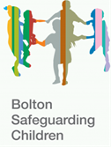](https://www.sharples-pri.bolton.sch.uk/wp-content/uploads/2021/02/Picture212.png) 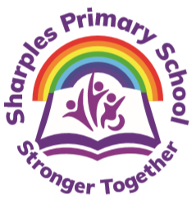

[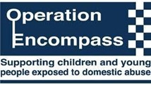](https://www.sharples-pri.bolton.sch.uk/wp-content/uploads/2021/02/Picture1.jpg)

Operation Encompass directly connects the police with schools to ensure support for children living with domestic abuse in their homes when there has been a police attended incident of Domestic Abuse. Rapid provision of support within the school environment means children are better safeguarded against the short-, medium- and long-term effects of domestic abuse. It provides an efficient, confidential channel of communication between police forces and Key Adults within schools. This enables the immediate and discrete recognition of the child’s situation by the Key Adult, ensuring a secure and sympathetic environment is provided and the broader effects of abuse are addressed. The purpose and procedures in Operation Encompass are detailed as part of the school’s Safeguarding Policy and published on our school website. You can find out more using the link below:

[www.operationencompass.org](http://www.operationencompass.org/)

At Sharples Primary School our key adults are Mrs J Samways (Designated Safeguarding Lead/Deputy Headteacher) and Mrs G Partington  (Deputy Safeguarding Lead/ Headteacher)