Our Mental Health Pledge
As a school we will:
- Champion whole school approaches to sustainably build a mentally healthy school community.
- Emphasise the importance of staff wellbeing as a necessity for the wellbeing of the children they teach and support
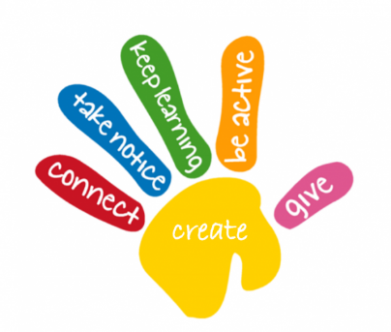
- Promote Five Ways to Well-Being for all staff and children
Our staff and children will be encouraged to:
- Connect with the people around me
- Be active in a way that suits us and that we enjoy
- Take notice and be mindful of our surroundings
- Keep learning new skills and developing ourselves
- Give what we can whether it is our time or simply a random act of kindness
- Highlight the connections between nutrition, physical, emotional and mental health
- Train our staff in mental health awareness so they can support children in our school
- Engage parents in conversations about children’s mental health to foster support at home
- Seek and share good practice from other schools
- Actively promote role of Mental Health Ambassadors within our school
- Work with PE providers and other organisations to promote children and young people’s mental wellbeing through physical activity and active lifestyle choices. Children will be encouraged to do the Daily Mile
- Work with Bolton CAMHS Mental Health Support Team to support children and deliver evidence based interventions for mild to moderate mental health issues
- Regularly review staff workload and working hours, ensuring routine working practices are emotionally friendly and compatible with family life
- Train our staff in mental health awareness and support honest conversations about mental health in our workplace community
- Have clear signposting to further help and resources for those who may need it

