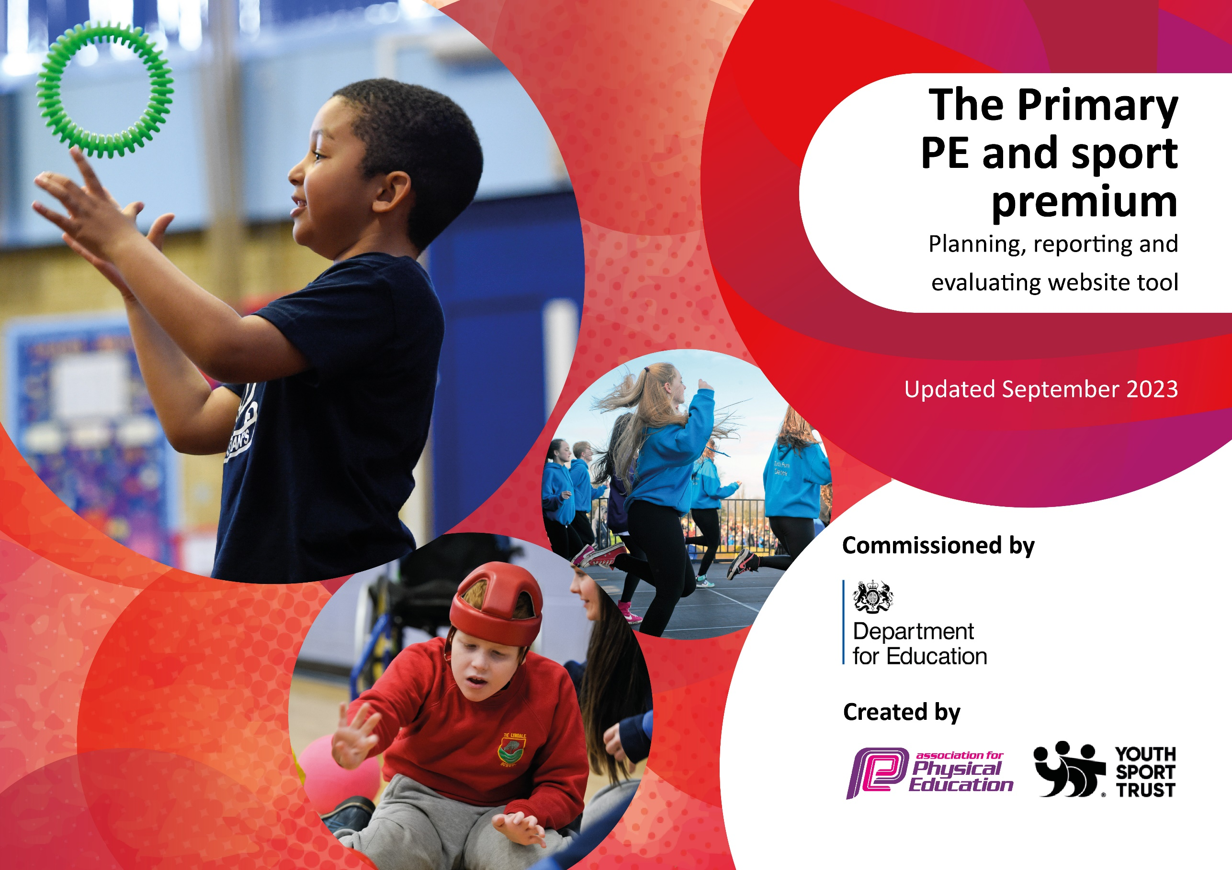

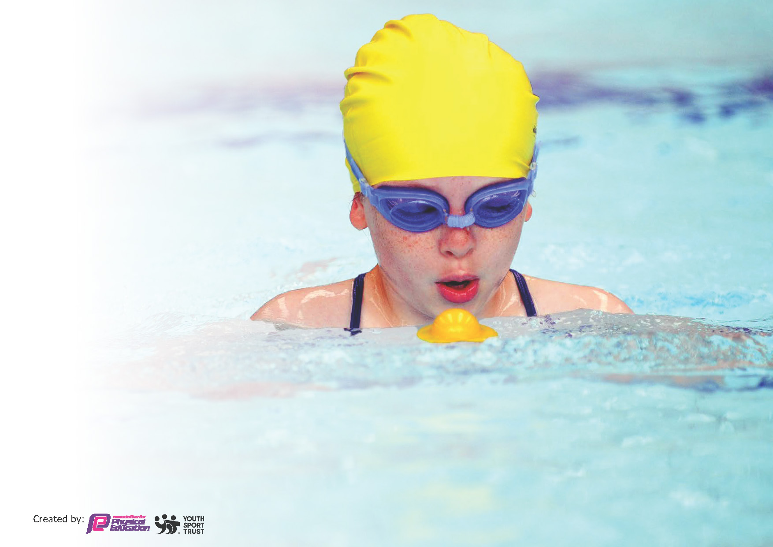
This template can be used for multiple purposes:
by:
- It enables schools to effectively plan their use of the Primary PE and sport premium
- It helps schools to meet the requirements (as set out in guidance) to publish information on their Primary PE and sport premium
- It will be an effective document to support Ofsted inspections enabling schools to evidence progress in Physical Education (PE) and evidence swimming attainment, which forms part of the PE National Curriculum. We would recommend schools consider
the Intent, Implementation and Impact of any spend, as examined within the Education Inspection Framework.

It is important that your grant is used effectively and based on school need.

Schools must use the funding to make additional and sustainable
improvements to the quality of the PE, School Sport and Physical Activity (PESSPA)
they offer. This means that you should use the Primary PE and sport premium to:

- Build capacity and capability within the school to ensure that improvements made now will benefit pupils joining the school in future years
- Develop or add to the PESSPA activities that your school already offers.

The Primary PE and sport premium should not be used to fund capital spend projects; the school’s core budget should fund these. Further detail on capital expenditure can be found in the updated Primary PE and sport premium guidance.

The Primary PE and sport premium guidance, outlines 5 key priorities that funding should be used towards. It is not

necessary that spending has to meet all the key priorities, you should select the priorities that you aim to use any funding towards.

Although completing this template is not a requirement for schools, schools are required to publish details of how they spend this funding. Schools must also outline what the impact this funding has had on pupils’ PE and sport participation and attainment and how any spending will be sustainable in the future. All funding must be spent by 31st July 2024.

The Department for Education has worked closely with the Association for Physical Education (afPE) and the Youth Sport Trust (YST) to develop this template and encourages schools to use it. This template is an effective way of meeting the reporting requirements of the Primary PE and sport premium.
Review of last year’s spend and key achievements (2022/2023)

We recommend you start by reflecting on the impact of current provision and reviewing your previous spend.

Activity/Action | Impact | Comments
Target SEND children and engage them in physical activity.  Continue to engage with School Games Competitions.  Enter some ‘Excel’ competitions, especially for Gymnastics.  Organise and run more intra-school competitions so more children are given the opportunity to play competitive sport.  Increase physical activity and time spent in the outdoors through Forest School session. | Higher engagement in SEND children in sport.  Achieved School Games Gold Award for the second year running. More children had the opportunity to represent school and discover new sports.  Entered Excel Gymnastics competition and children medaled across the disciplines in this event.  All children in school had the opportunity to play competitive sport through lunch time house competitions.  All children in school took part in Forest School sessions as part of their curricular learning. | This supported the wellbeing and personal development of these children. SEND events were well organized and made links with BWiTC.  School should continue to engage with the schools games coordinators as these provide a wealth of opportunities for our pupils.  Continue with gymnastics coach and VH to support competition.  Continue to develop play at lunchtime going forward so more children are engaged and physically active.  This supported the wellbeing and personal development of these children. Forest area needs developing.

Key priorities and Planning
This planning template will allow schools to accurately plan their spending.

Action – what are you planning to do | Who does this action impact? | Key indicator to meet | Impacts and how sustainability will be achieved? | Cost linked to the action
Develop Orienteering activities and CPD for staff.  Active Boards  Engagement in Your School Games Competitions.  Increase Intra-school sport  Increase engagement in extra-curricular sporting clubs.  CPD for teachers.  Forest School Provision for all pupils | Teaching staff to attend CPD for how to teach OAA and how to use the orienteering markers for cross curricular learning.  Children will gain new knowledge of OAA activities and will increase physical activity in other areas of the curriculum.  Children will have more opportunities for physical exercise during playtimes.  Children will have more opportunities for competitive sport. Children will access a wider variety of sports.  All Children will have opportunities for competitive sport. Children will access a wider variety of sports.  Children will have the opportunity to attend a variety of sporting clubs.  Teaching staff will be upskilled in how to teach PE and Sports.  All classes timetabled for Forest School activities. | Key indicator 1: Increased confidence, knowledge and skills of all staff in teaching PE and sport  Key indicator 2 -The engagement of all pupils in regular physical activity.  Key indicator 4: Broader experience of a range of sports and activities offered to all pupils.  Key indicator 2 -The engagement of all pupils in regular physical activity.  Key indicator 3- The profile of PE and Sport is raised across the school as a tool for whole school improvement.  Key indicator 5: Increased participation in competitive sport  Key indicator 3- The profile of PE and Sport is raised across the school as a tool for whole school improvement.  Key indicator 5: Increased participation in competitive sport  Key indicator 2 -The engagement of all pupils in regular physical activity.  Key indicator 4: Broader experience of a range of sports and activities offered to all pupils.  Key indicator 1: Increased confidence, knowledge and skills of all staff in teaching PE and sport  Key indicator 2 -The engagement of all pupils in regular physical activity.  Key indicator 4: Broader experience of a range of sports and activities offered to all pupils.  Key indicator 2 -The engagement of all pupils in regular physical activity.  Key indicator 4: Broader experience of a range of sports and activities offered to all pupils. | More pupils meeting their daily physical activity goal, more pupils encouraged to take part in PE and Sport Activities.  Teaching staff to be upskilled in the teaching of orienteering and how to use it to teach content across the curriculum.  More pupils will meet their daily physical active goal.  Children will know how to play a wider range of sports. They develop interests in new sports that may lead to joining clubs out of school. Personal development from attending competitive sport.  Children will have experience of competitive sport during the school day.  Children will participate in a greater variety of sports.  Primary teachers more confident to deliver effective PE supporting pupils to undertake extra activities inside and outside of school, including teaching water safety and swimming and as a result improved % of pupil’s attainment in PE.  All children in school have had the opportunity to learn in the woodland area. Physical activity and time spent outside has increased for all pupils. | £2,500.  £7,800  £2000  £1000  £1500  £2000  £900

Key achievements 2023-2024
This template will be completed at the end of the academic year and will showcase the key achievements schools have made with their Primary PE and sport premium spending.

Activity/Action | Impact | Comments
Develop Orienteering activities and CPD for staff.  Active Boards  Engagement in Your School Games.  Increase Intra-school sport  Increase engagement in extra-curricular sporting clubs.  CPD for teachers  Forest School Provision for all pupils | The profile of Orienteering has been raised and there is now a sequence and progression to OAA teaching. All staff received training and are confident to deliver PE sessions on Orienteering. Children have all been taught orienteering during curriculum lessons and this has also extended into cross-curricular too.  The boards have been used to increase engagement in physical activity at playtimes. Timetabled and staffed to ensure equal opportunity.  We have attended 15 different events in 8 different sports including SEND events. We have also attended cluster group competitions, tournaments run by the local high school and Visual Impairment specific SEND competitions.  All children in KS1&2 have taken part in intra school competitions in various sports.  A wide range of clubs have been offered to children and take up of these clubs has been high on the whole. Rotation of sports each term. ECT staff have been involved in leading clubs. Clubs have lead onto competitions of festivals.  Staff have all received CPD for the structure and delivery of PE lessons, gymnastics, OAA, Boccia, Tri Golf and Orienteering.  Staff member has been released to deliver forest school and OAA activities. All children in school have regular access to the forest and OAA activities. | This has been a huge success. Teachers are now finding opportunities to use the Orienteering resources within their teaching across a range of subjects. All children have become more active in these lessons. Children are skilled at Orienteering and have high success rates.  Next year use these to target groups of children. Also train playground leaders to use them and support the younger children in playing with them.  We have seen good achievements in Girls’ Football (winning the Sharples High School festival, runners up in the cluster competition and the semi-final of the School Games competition) and Gymnastics (winning a variety of medals across the disciplines for KS2).  Continue to provide intra school competitions. Link to curriculum lessons.  Highly successful. Next year to include some lesser known sports. Also to target those children who do not attend any clubs.  Staff skilled in different PE disciplines. This will be evident in high quality PE lessons. Orienteering CPD delivered in Spring Term has had a huge impact on staff confidence with orienteering delivery and use of it across the curriculum too.  School have also funded the development of the forest area, showing high investment in outdoor learning. This will enable sustained delivery of outdoor education.

Swimming Data
Meeting National Curriculum requirements for swimming and water safety.
Priority should always be given to ensuring that pupils can perform safe self-rescue even if they do not fully meet the first two requirements of the National Curriculum programme of study

Question | Stats: | Further context  Relative to local challenges
What percentage of your current Year 6 cohort can swim competently, confidently and proficiently over a distance of at least 25 metres? | 73%
What percentage of your current Year 6 cohort can use a range of strokes effectively [for example, front crawl, backstroke, and breaststroke]? | 65%

What percentage of your current Year 6 cohort are able to perform safe self-rescue in different water-based situations? | 73%
If your schools swimming data is below national expectation, you can choose to use the Primary PE and sport premium to provide additional top-up sessions for those pupils that did not meet National Curriculum  requirements after the completion of core lessons. Have you done this? | Yes/No | There was not the available pool space for this to happen this year. This will be in pace again next year.
Have you provided CPD to improve the knowledge and confidence of staff to be able to teach swimming and water safety? | Yes/No | Swimming and Water Safety is taught by an external provider.

Signed off by:

Head Teacher: | Gemma Partington
Subject Leader: | Vicki Hamer  PE Lead
Date: | July 2024

